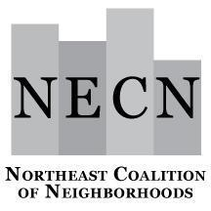

NECN Board of Directors Meeting
Tuesday, February 20, 2024
6:30 – 8:00 p.m.
Zoom Link

Meeting Agenda

6:30 p.m. Welcome, Introductions (Jimmy and Sean)
Review Agenda

6:35 p.m. Read & Discuss Proposed Bylaws Amendment (Robert/Sean)
(vote may take place this Board meeting)

Proposed Bylaws Amendment: Change NECN Bylaws Article 1, Section 3 to say “NECN’s service area shall include the City of Portland City Council District 2 boundaries.”

6:40 p.m. Possible NECN/Civic Life Budget Amendment (Jona)

6:50 p.m. Neighborhood Updates/Announcements (Everyone)

7:00 p.m. District 2 Discussion (Jimmy and Sean)

8:00 p.m. Meeting Adjourn

- Next Joint Meeting on District 2 - TBD

Next Board Meeting: Tuesday, March 19, at 6:30 p.m.

